Serial No: IIMS/CMDP/WO-XX/01
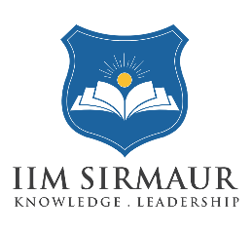

भारतीय प्रबन्ध संस्थान सिरमौर

Indian Institute of Management Sirmaur

Management Development Programme

This is to certify that Mr./Miss XYZ from “Parent Organization” has successfully participated in the Management Development Programme titled “yyyyyyyyyy” held from April 12- September 12,2025 at the Indian Institute of Management Sirmaur.

Programme Director Programme Director CMDP Chairperson

